**Guardian of Health Safety**

**Introduction:** In this project we will make a temperature sensor door lock system. This lock system works when the temperature within 97 $℉$ to 99 $℉$. When the temperature is within this range the door will be opened otherwise the door will be closed.

This is one of the unique projects which has combined two systems with one another and makes single once.

**Motivation:** Few daysago, was worse than ever. The death rate was increasing day by day. The main reason of it is spreading. We know Corona virus can easily spread from person to person. But if we become aware we can easily end this epidemic. One of the symptoms of Covid-19 is fever. So that our body temperature will rise up than normal temperature. If we protect our home, office or market from those persons whose body temperature is higher than normal ones then we can get rid of this virus.

Guard will measure body temperature and whose body temperature is higher, he will refrain those persons to get in the institute. But this process is time dependent and costly.

So, we decided to make a system which will save time and money and can be used in anywhere. This idea encouraged us to develop this project.

**Objectives:** Ourprojectobjectives are:

1. Easy maintain ace
2. Automation
3. Accurate temperature detection
4. Auto handwash
5. Can be use in anywhere

**Equipment:** In this project we have used several components to develop our system.

Arduino Uno: We can say this is the mother of whole system. Every component such as sensor, motor, lcd get power from it. It is a microcontroller board based on the ATmega328P. It has 14 digital input/output pins (of which 6 can be used as PWM outputs), 6 analogue inputs, a 16 MHz quartz crystal, a USB connection, a power jack, an ICSP header and a reset button. It contains everything needed to support the microcontroller; simply connect it to a computer with a USB cable or power it with a AC-to-DC adapter or battery to get started. Here we upload program to run the components sequentially.

MLX90614: It is an infrared contactless temperature sensor which detects ambient and object temperature. In this system this component will measure body temperature.

It can measure temperature from -70 $℃$ to 382.2 $℃$. The sensor uses IR rays to measure the temperature of the object without any physical contact and communicates to the microcontroller using the I2C protocol. It has four inputs SDA, SCL, VCC, GND.

SCL and SDA will connect Arduino A4 and A5 port, VCC connects to Arduino 3.3V port and GND connects to GND port.

Servo Motor: It is a rotary actuator or linear actuator that allows for precise control of angular or linear position, velocity, and acceleration. It consists of a suitable motor coupled to a sensor for position feedback. It is used to develop automatic door lock system.

It has total 3 inputs. The red wire will connect to Arduino 5v, grey wire connects to GND port and yellow wire connects to 3number port.

LCD: A liquid-crystal display (LCD) is a [flat-panel display](https://en.wikipedia.org/wiki/Flat_panel_display) or other [electronically modulated optical device](https://en.wikipedia.org/wiki/Electro-optic_modulator) that uses the light-modulating properties of [liquid crystals](https://en.wikipedia.org/wiki/Liquid_crystal) combined with [polarizers](https://en.wikipedia.org/wiki/Polarizer). In this project it will show some messages based on the temperature changes. When temperature is normal it will show “Temp: 98 $℉$ Please Enter” or when temperature is high it will show “May Coved Positive Please Return” otherwise it will show “Please wait…”.

I2C Device: Inter-integrated circuit (I2C) a serial protocol for devices to communicate with one another. I2C is a serial protocol because it has a clock line and single data line which is used for both sending and receiving data. This is used to reduce the connection of number of wires.

It has 4 inputs SCL, SDA, VCC and GND. SCL and SDA connect to the Arduino SCL and SDA port, VCC connect to the 5v port and GND connects to the GND port.

Ultrasonic Sensor: An ultrasonic sensor is an instrument that measures the distance to an object using ultrasonic sound waves.

It has 4 input pins. Two for ground and VCC and others two are trig and echo pin.

Breadboard: It is a construction base for prototyping of electronics. In this board we have connected our several components.

Jumper Wire: These wires are used to connect devices with one another. We have use male to female and male to male wires.

**Working Process:** At first, we have uploaded code in Arduino. The temperature sensor will measure temperature continuously. When the temperature is 96 $℉$ or up to 96 $℉$, it will stop for 1000 or 1sec. Then it collects five records of body temperature and find out its average. If the temperature is 96 $℉$ to 99 $℉$ lcd will show “Temp: Wash Hand in 5 sec”. After Washing hand another signal will go to servo motor and then it will rotate 10 $°$ to 110 $°$. After 3 sec it will return back to its previous position. Then the system will record how many people pass the door. Thus, our system works for temperature 96 $℉$ to 99 $℉$.

There is another condition here. If someone’s does not wash hand after seeing the message “Temp: Wash Hand in 5 sec” he/she can not pass the door. In fact, the servo motor will fix its current position and lcd will show “Time out Go back”.

If the someone’s temperature is up to 99 $℉$ then the motor will fix to 10 $°$ position and lcd will show “May Covid Positive Please Return”. It will not change its position. As well as the person whose body temperature is up to 99 $℉$, he/she can’t use auto handwash system. When the sensor measuring body temperature servomotor will fix to 10 $°$ position and lcd will show “Please wait…” message.

This is our system working process.

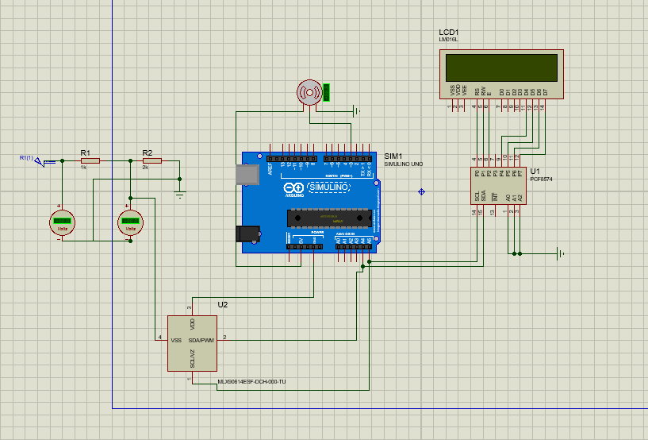

**LCD**

**Servomotor**

**PCF8574**

**Arduino Uno**

**MLX90614**

Proteus simulation of the project

**Project Outcomes:** Our project goal is to prevent Covid-19 and others infectious diseases at any cost so that we are developing a system which is very much effective to prevent those kinds of infectious diseases.

This technology allows to prevent entering an infectious person in any institution without assistance of guards or volunteers. Besides it will guide a person to wash his/her cloths and hands by germ cleaner so that there is no chance of spreading virus to others persons. This technology is very cheap to purchase.

Thus we will develop the guardian of health safety in every educational institution, government institution and other public places.

Report of how corona virus severely transmitted in 2020 from March to May from one person to another

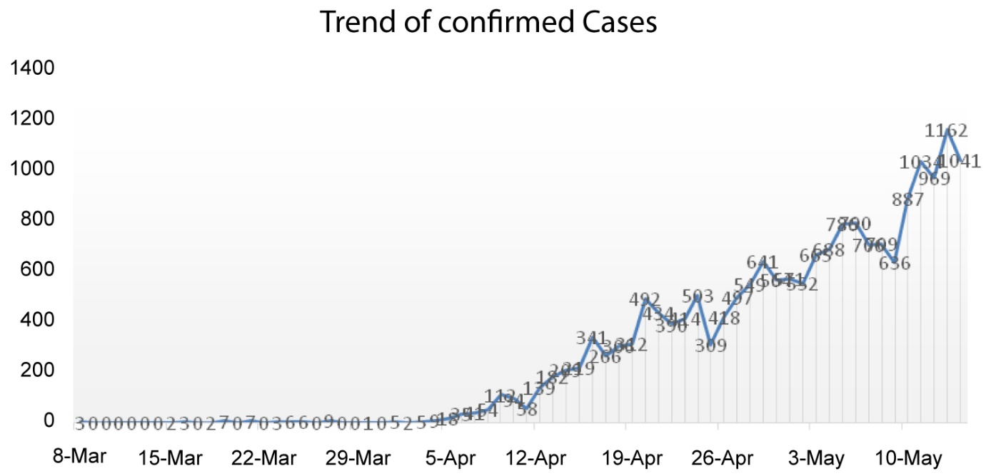

So that we can observe the importance of this technology.

**Future Plan:** In futurewe want to promote this technology more efficiently so that user can purchase at cheap price.